A

HARDWARE MINI PROJECT REPORT

ON

**HOME AUTOMATION USING ARDUINO UNO**

Presented by

**Mr. ADITYA KAPASE**

**Mr. PRATIK MORE**

**Mr. BALAJI AMBHORE**

# of Class T. Y. (Electronics & Telecommunication engineering)

for the partial fulfillment of Semester - V of T. Y. (E&TC Engineering)



**Under the guidance**

**Of**

(**Prof.P.C.Dhavle**)

**SES’s A. G. Patil Institute of Technology, Solapur Department of Electronics & Telecommunication Engineering.**



**CERTIFICATE**

This is to certify that **Shekhar Diwate.**  Roll No. (**09**), **Shubham Hande .**Roll No’.(**14**), **Balaji Ambhore .**Roll No. (**01**),of 3rd year class Electronics and Telecommunication Engineering have effectively delivered presentation and have successfully submitted the hardware mini project and report in satisfactory manner for the partial fulfillment of Semester - V of T. Y. (E&TC Engineering) at the Department of Electronics and Telecommunication Engineering at SES’s A. G. Patil Institute of Technology, Solapur.

**Prof. P. C. Dhavle. Dr. R. V. Darekar.**

Subject Incharge (H.O.D)

# ABSTRACT

The main objective of this project is to develop a smart home automation system using an Arduino board with Bluetooth module HC-05 being remotely controlled by any Android OS smart phone. As technology is advancing day by day, so houses are also getting smarter. Modern houses are gradually shifting from conventional switches to centralized control system, involving remote controlled switches. Presently, conventional wall switches located in different parts of the house makes it difficult for the user to go near them to operate. Even more it becomes more difficult for the elderly or physically handicapped people to do so. Remote controlled home automation system provides a most modern solution with smart phones.

In order to achieve this, a Bluetooth module is interfaced to the Arduino board at the receiver end while on the transmitter end, a GUI application on the cell phone sends ON/OFF commands to the receiver where loads are connected. By touching the specified location on the GUI, the loads can be turned ON/OFF remotely through this technology. The loads are operated by Arduino board through 5 volt relays.

**INDEX**

|  |  |  |
| --- | --- | --- |
| **SR** | **CONTENT** | **P. NO.** |
| **1.** | **TITLE** | 1 |
| **2.** | **ABSTRACT** | 3 |
| **3.** | **INTRODUCTION** | 5 |
| **4.** | **CIRCUIT DIAGRAM** | 6 |
| **5.** | **LITERATURE REVIEW** | 7 |
| **6.** | **METHODOLOGY** | 8 |
| **7.** | **WORKING PRINCIPLE** | 9 |
| **8.** | COMPONENTS REQUIRED | 11 |
| **9.** | **BLOCK DIAGRAM** | 14 |
| **10.** | **FLOW CHART** | 15 |
| **11.** | **PROJECT RESULT** | 16 |
| **12.** | **CONCLUSION** | 17 |
| **13.** | **REFERENCE** | 18 |

# 

# INTRODUCTION

Home automation refers to the control of home devices such as lights, fans, heating systems, security cameras, and other appliances via a centralized system, often through wireless communication. With the rapid advancement of technology, home automation has become an integral part of modern living, providing convenience, energy efficiency, and security. The primary goal of home automation is to make daily tasks easier, enhance comfort, and reduce the need for manual intervention.

The project at hand focuses on creating a **home automation system using Arduino Uno** and a **Bluetooth module (HC-05)**, which allows users to control home appliances wirelessly from a smartphone or Bluetooth-enabled device. The use of **Arduino Uno**, a low-cost and easily programmable microcontroller board, and the **HC-05 Bluetooth module**, a widely used Bluetooth communication device, makes this system both affordable and flexible for various applications.

**Circuit diagram**

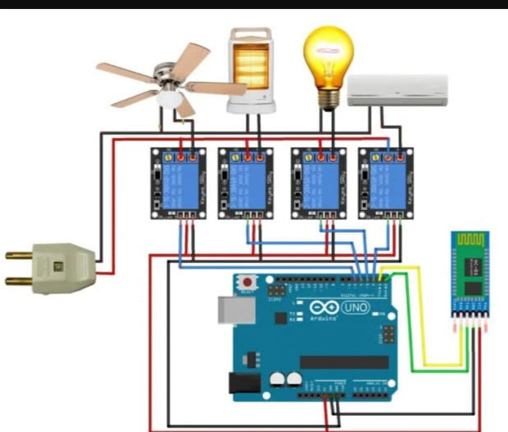

**Literature Review**

Home automation has emerged as an essential technology to enhance convenience, security, and energy efficiency in residential spaces. The Arduino Uno, a widely used microcontroller, has become a cornerstone in DIY home automation projects due to its affordability, simplicity, and vast online support. The Arduino platform is particularly advantageous in this field because of its ease of integration with various components such as sensors, actuators, and communication modules, allowing users to create customized automation systems. Bluetooth, specifically the HC-05 module, plays a significant role in enabling wireless communication between the Arduino and mobile devices. This wireless technology offers a straightforward way to control home appliances remotely via a smartphone, providing flexibility and ease of use. The HC-05 module, with its short-range communication capabilities, is well-suited for small-scale home automation systems where devices are controlled within a limited range, typically within a single room or house.

The use of a 4-channel relay module in conjunction with the Arduino and Bluetooth module allows for the control of multiple home appliances simultaneously, such as lights, fans, and other electrical devices. The relay acts as an electrically controlled switch, allowing the low-voltage Arduino system to control higher voltage circuits safely. This integration makes it possible to automate and remotely control several household systems without the need for complex wiring. In this setup, the relay modules are activated by signals from the Arduino, which in turn receive commands from the Bluetooth module, enabling users to turn appliances on or off with their mobile devices. Several studies and projects have demonstrated this integration, highlighting its cost-effectiveness and practicality for creating simple smart home solutions. For instance, mobile apps are commonly used to send control commands to the system, allowing users to monitor and control appliances in real-time, thus making home automation more accessible and user-friendly.

While the combination of Arduino, HC-05 Bluetooth, and a 4-channel relay provides an efficient and affordable solution for home automation, there are some challenges that need to be addressed. Bluetooth communication is limited by its range, typically around 10 meters, which may be insufficient for larger homes or multi-story buildings. Additionally, the power consumption of relay modules, which manage high-power appliances, can become a concern, especially in systems running multiple devices. Security is also a critical issue, as Bluetooth connections can be vulnerable to unauthorized access. Implementing encryption and secure communication protocols is essential for ensuring the system’s safety and privacy. Despite these challenges, the integration of these technologies continues to be a promising solution for small to medium-scale home automation systems, and ongoing advancements in microcontroller and wireless communication technologies hold the potential for even more efficient and scalable systems in the future.

**METHODOLOGY**

The methodology for implementing home automation using Arduino Uno, HC-05 Bluetooth module, and a 4-channel relay module involves several systematic steps, including hardware setup, software development, and testing. The goal is to create a simple, cost-effective, and user-friendly system for controlling home appliances wirelessly.

First, the hardware components are assembled. The HC-05 Bluetooth module is connected to the Arduino Uno, with its VCC and GND pins connected to the Arduino's 5V and GND, respectively. The RX pin of the HC-05 connects to the Arduino TX pin, and its TX pin connects to the Arduino RX pin. For compatibility with 3.3V logic on the HC-05, a voltage divider is used on the RX line if required. The 4-channel relay module is connected to the Arduino, with its VCC and GND pins connected to the Arduino's 5V and GND, and its input pins (IN1-IN4) connected to digital pins on the Arduino (e.g., D2, D3, D4, D5). Household appliances are wired to the relay module terminals (COM, NO, NC) as per safety guidelines.

Next, the Arduino is programmed using the Arduino IDE. The code initializes the Bluetooth communication, sets up the relay control pins, and processes commands received from a paired smartphone via the HC-05 module. The smartphone sends commands such as '1' to turn on an appliance and '2' to turn it off. Each command corresponds to a specific relay control action. For Bluetooth control, an existing app like “Arduino Bluetooth Controller” or a custom-built app is used to send these commands.

The system is tested thoroughly. Initially, the Bluetooth module’s pairing and command transmission are validated. Next, the relay module's response to commands is checked to ensure that appliances toggle correctly. Finally, the entire setup is tested with appliances to confirm end-to-end functionality.

Safety measures include proper insulation of wires, using relays with adequate current ratings, and ensuring electrical isolation with optocouplers. This standalone system is designed to be scalable, allowing the integration of additional features like IoT connectivity for remote control or voice command support in the future.

**WORKING PRINCIPLE**

The home automation system operates by integrating Arduino Uno, a Bluetooth module (HC-05), and a 4-channel relay module. Its main purpose is to control electrical appliances wirelessly through a smartphone application. Below is a detailed explanation of the working principle:

#### **1. Initialization**

* **Arduino Uno**: Acts as the central processing unit, controlling relays based on commands received via Bluetooth.
* **HC-05 Bluetooth Module**: Facilitates wireless communication between the smartphone and the Arduino. It receives commands from the smartphone and transmits them to the Arduino.
* **Relay Module**: Controls the electrical appliances by toggling their power states (ON/OFF) based on signals from the Arduino.

#### **2. Bluetooth Communication**

The HC-05 Bluetooth module pairs with a smartphone app, such as **Arduino Bluetooth Controller** or any other compatible Bluetooth control application. Once paired, the app sends commands in the form of characters (e.g., '1' to turn ON an appliance and '2' to turn it OFF).

#### **3. Command Processing**

1. When a command is sent from the smartphone, it is received by the HC-05 module.
2. The HC-05 transmits this command to the Arduino via its RX pin.
3. The Arduino processes the received command using a predefined program. Each command corresponds to a specific action:
   * For example:
     + '1': Turn ON Relay 1 (e.g., light).
     + '2': Turn OFF Relay 1.
     + '3': Turn ON Relay 2 (e.g., fan).
     + '4': Turn OFF Relay 2.
4. Based on the command, the Arduino sends a HIGH or LOW signal to the respective relay pin.

#### **4. Appliance Control**

* **Relay Functionality**: The relay acts as a switch for the connected appliances:
  + A LOW signal from the Arduino closes the relay circuit (turns the appliance ON).
  + A HIGH signal from the Arduino opens the relay circuit (turns the appliance OFF).
* Appliances are connected to the relay module's **COM (common)** and either **NO (Normally Open)** or **NC (Normally Closed)** terminals, depending on the desired default state.

#### **5. Real-Time Control**

* The user sends commands in real time via the smartphone app.
* The HC-05 Bluetooth module communicates these commands to the Arduino, which processes them and controls the respective relay channels.
* The relays toggle the connected appliances, providing immediate feedback.

#### **6. Safety and Efficiency**

* Proper electrical insulation and rated relays ensure safe operation.
* This system reduces energy wastage by allowing users to turn appliances ON/OFF only when needed.
* No manual intervention is required, as appliances can be controlled remotely.

#### **Example Use Case**

* The user opens the smartphone app and pairs it with the HC-05 module.
* To turn ON a light connected to Relay 1, the user sends the command '1'.
* The HC-05 transmits this command to the Arduino, which processes it and sends a LOW signal to Relay 1.
* Relay 1 closes the circuit, turning the light ON.
* To turn the light OFF, the user sends '2', and the process is reversed.

This working principle ensures a reliable and user-friendly approach to automating home appliances, offering convenience, energy efficiency, and a foundation for future expansions, such as integrating IoT or voice control.

# COMPONENTS REQUIRED

• **Arduino Uno**: Acts as the microcontroller to process commands.

• **HC-05 Bluetooth Module**: Enables wireless communication between Arduino and smartphone.

• **4-Channel Relay Module**: Controls the electrical appliances by acting as a switch.

• **Smartphone with Bluetooth App**: Sends control commands to the HC-05 module.

• **Power Supply**: Powers the Arduino and relay module.

• **Connecting Wires**: For making circuit connections.

• **Household Appliances**: Devices to be automated (e.g., lights, fans).

**Arduino UNO**

* The Arduino Uno is one of the most popular and widely used microcontroller boards in the Arduino family. It is based on the ATmega328P microcontroller and is designed for beginners and hobbyists in electronics and programming.

**Key Components:-**

* 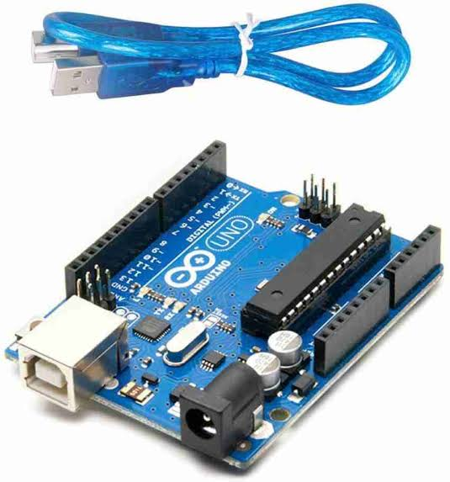Microcontroller: ATmega328P
* Operating Voltage: 5V
* Input Voltage: 7-12V
* Digital I/O Pins: 14
* Analog Input Pins: 6
* Clock Speed: 16 MHz
* SRAM: 2 KB
* EEPROM: 1 KB
* Flash Memory: 32 KB (0.5 KB used by bootloader)

**HC-05 Bluetooth Module**

* **Home automation** : Control lights, fans and other home appliances remotely .
* **Data logging**: Send sensor data from various sensors to a computer or smartphone for monitoring and analysis IoT applications Enable smart devices to communicate with each other or with a central controller

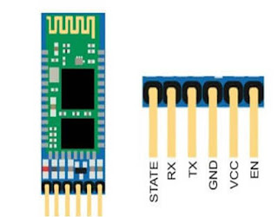

**RELAY MODULE**

* A relay module is a switching device that allows low-power signals to control high-power circuits.
* They are used in many applications including Automation systems Relay modules can be used to control devices like lights and motors in automated systems.

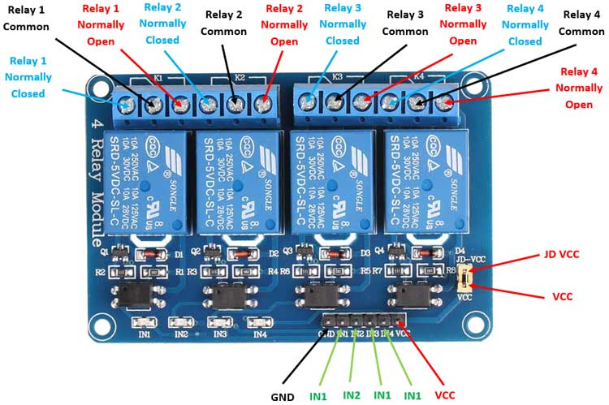

# BLOCK DIAGRAM

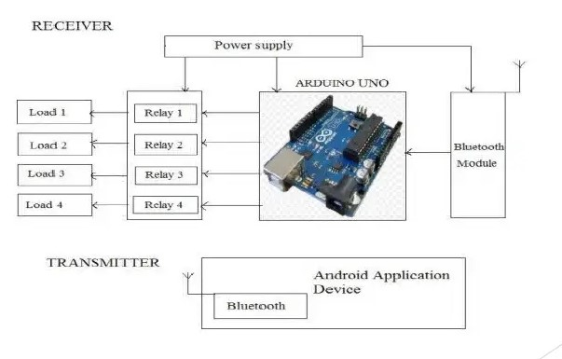

**Flowchart**

Start  
 ↓

Power ON System  
 ↓

Initialize Arduino and HC-05 Module  
 ↓

Pair Smartphone with HC-05 Bluetooth Module  
 ↓

Open Smartphone App and Send Command  
 ↓

HC-05 Receives Command  
 ↓

Command Sent to Arduino for Processing  
 ↓

Check Command

**Project Result**

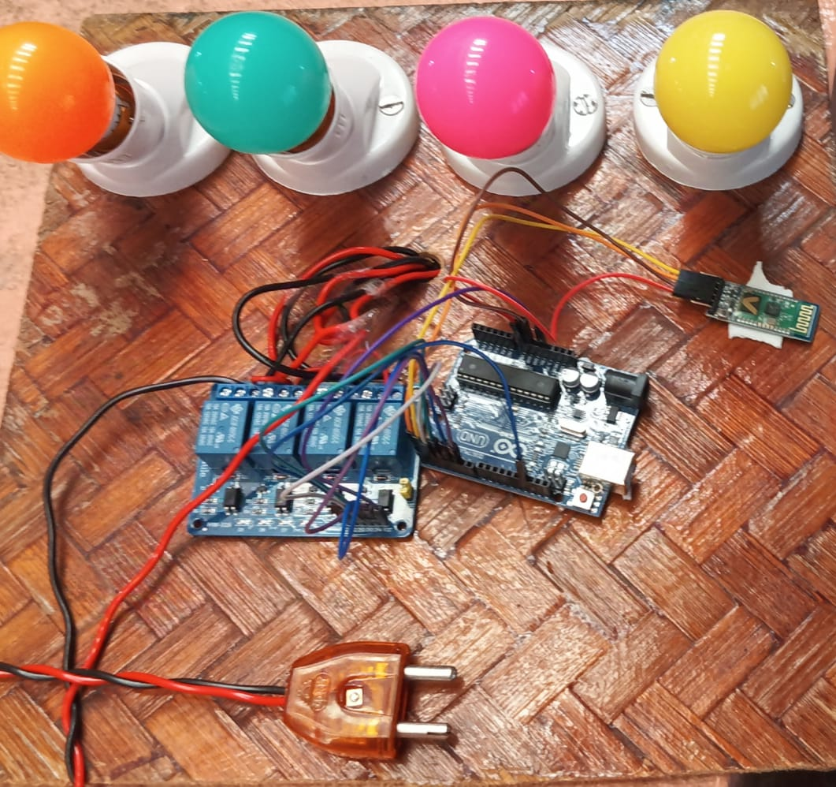

**Conclusion**

In conclusion, the home automation system using Arduino Uno, HC-05 Bluetooth module, and a 4-channel relay module offers an efficient, cost-effective, and user-friendly solution for controlling household appliances wirelessly. The system improves convenience by allowing appliances to be controlled remotely via a smartphone, reducing the need for manual interaction with switches. Additionally, it helps save energy by ensuring appliances are only turned on when needed. The project is scalable, reliable, and safe, making it a practical solution for modernizing home automation. This system can be further enhanced with features like IoT integration or voice control for added functionality.

**Reference:**

in intelligent transportation systems”, New Mexico State University, Tech. The report, 2007.

* Shaheen, S., et al. (2005). "Smart Vehicle Parking Systems and Technology: A Survey." Transportation Research Part C, 13(5), 399-414.
  + Discusses automation systems, relevant to understanding smart control.
* Nair, M., & Aravind, M. (2017). "Home Automation Using Arduino and Bluetooth." International Journal of Advanced Research in Computer Science, 8(3), 92-95.
  + Explores Arduino and Bluetooth integration in home automation.
* Khanna, S., & Agarwal, P. (2018). "Home Automation Using Arduino and Bluetooth." International Journal of Computer Science and Mobile Computing, 7(5), 204-209.
  + Focuses on Bluetooth-based home automation using Arduino.
* Caytan, M., & Erturk, E. (2014). "Development of an IoT Based Home Automation System Using Arduino." International Conference on Future Networks and Communications.
  + Explores Arduino-based IoT home automation.
* Bhai, B., & Thakare, A. (2016). "Arduino-Based Home Automation with Bluetooth." International Journal of Electronics and Communication Engineering, 5(3), 25-32.
  + Examines Bluetooth and Arduino in home automation.
* Arduino Official Documentation (2024). [Arduino - Home](https://www.arduino.cc).
  + Technical resources on Arduino Uno and Bluetooth modules.

Tuticorin District Using Landsat Images”, IJIEST ISSN (2455-8494), Vol.03, No. 01, Jan 2018.